**Commensality: Beyond the Belief That You Are What You Eat.**

*Aotearoa, New Zealand is both a bicultural nation and a multicultural society. So the need to prioritize culture in design pedagogy and practice is not only palpable but well overdue within our creative tertiary institutes. Although acknowledged as highly valuable within higher education, diversities when explored as non-western cultural and creative practices are still side-lined as optional or as extensions to the current teleological pathways carved out within tertiary design curricula and practice. Building on the ‘indigenous wisdom’ framework outlined in the emergent design provocation Transition Design, this research introduces how an appreciation of cultural acumen can benefit, enrich, critique, and radicalise current design thinking, process and praxis. This study will discuss both Māori and Pasifika world views and ideologies and illustrate how these can enrich and enable design education. The aim of this paper is to highlight an appreciation for the reciprocity and respect imbued within kaupapa Māori and the Pasifika ideology of Ta Vā (time and space) and how these considerations can enhance the discipline when they are purposefully, knowingly and respectfully imbued in design thinking and praxis. This research specifically focuses on the establishment of connections as essential to both the discipline and the teaching and learning experience. To achieve this, this study will introduce commensality, the coming together around a table to break bread and boundaries, and place it within the framework of Transition Design. Having gained an appreciation of Transition Design, Māori and Pasifika world views and ideologies and commensality, this research will exemplar instances where students have combined these considerations to enhance their design solutions and also where pedagogy has used them to specifically enhance teaching and learning by enabling an appreciation of cultural identity and social connectivity within the learning space.*

*“It has come out of hiding and is now in the bright light of day.” (**Mead, 2006* *)*

Building on Transition Design’s belief that cultural acumen can enable modern society to better conceive solutions for sustainable futures, this research introduces how an appreciation of ‘indigenous wisdom’ and the symbiotic relationships embedded within it can benefit, enrich, critique and radicalise current design thinking, process and praxis. This study discusses both Māori and Pasifika world views and ideologies and illustrates how these can both enrich and enable design and design pedagogy education as they both grapples to engage with global issues that are now described as ‘wicked issues’. Anthropologist, historian, artist, teacher, writer and prominent Māori leader, Hirini Moko Mead argues that Māori knowledge needs to be understood, discussed, debated and passed on to others as there is every indication that *tikanga* Māori will become more important in the years to come rather than the reverse (Mead, 2006 ). This paper aims to highlight an appreciation for the reciprocity and respect imbued within indigenous practices, beliefs and ideologies and illustrate how these considerations can enhance design thinking and praxis when they are purposefully, knowingly and respectfully imbued in the theoretical frameworks, process and praxis of the discipline. To achieve this, this paper also incorporates Transition Design’s Cosmopolitan Localism perhaps more easily appreciated as The Everyday as a second and very important framework to this study. Transition Design takes the stance that everyday life is an important yet often overlooked context for understanding society (Terry Irwin, 2015). This study incorporates commensality, as its everyday context for inquiry.

The word commensality refers to the everyday practice of coming together around a table to eat. Until recently this has been one of those words hidden in academia, but this paper asserts it is time to shed some light on the advantages to reinstating commensality within a modern society that, this investigation posits, is plagued with issues activated and/or compounded by loneliness and a lack of social connectedness. Along with an appreciation of *kaupapa* Māori and the Pasifika ideology of *Ta Vā* (time and space) this research aims to use the everyday activity of commensality to discover both a new design tool and more culturally empathetic, inspired, and respectful design solutions that increase opportunities for social connectivity. As far back as the seventeenth century anthropologists have discussed commensality as having beneficial influences on establishing, maintaining and enriching social relationships among people. Commensality is a social act and involves rules of organisation, hierarchy, solidarity and boundary.(Kerner, 2015) But as importantly it involves people, food, rituals, time and space. This research uses commensality to frame Indigenous Wisdom and Everyday Life Discourse and compares traditional, historic and contemporary behaviours of shared meals to gain an understandings of reciprocity, generosity, respect and gratitude. These are all fundamental within the beliefs and practices of Māori and Pasifika cultures. Using the attributes of indigenous wisdom as agency for design this research focuses on commensality to explore and demonstrate ways in which the everyday human need of connectivity can better be served.

Although food is and always has been something that connects people emotionally and can bring them together, it also has the potential to teach, inspire and engage us in new and exciting experiences. Over the last few years new discourse concerning food, food issues and alternative food cultures has grown in both number and prominence. In the face of both a globalisation and homogenisation of food, the universal marketing supporting this and the explosion of instances of eating disorders and allergies, a public awareness of food experiences as a source of cultural identity, individual and collective health along with holistic well-being and communal welfare has taken root(1866). As a part of this growth, gastronomic tourism has also grown in popularity and offers significant support to local economies and to the development of cultural visibility and sustainability. So, with food acknowledged as a significant element within personal and cultural identities, new forms of communication and interaction with specific foods, food groups and food experiences are being developed. In the face of these developments this research seeks to step back from the considerations of what food is being prepared or eaten, or indeed how, this food is being prepared or eaten and explore what benefits lie in who this food is being eaten with, known as commensality. This study asks, how commensality can enhance well-being and as importantly how can design participate in that discourse?

Commensality is considered as the everyday practice of coming together around a table to eat. Challenging the adage *you are what you eat,* this research asserts we are also *who we eat with*. To quote the French philosopher, Michel Montaigne, “One must be careful not so much of what one eats as with whom one eats. There is no dish so sweet to me, and no sauce so appetizing as the pleasure derived from good company” (Ficshler, 2011). German sociologist, philosopher, and critic Georg Simmel (1858- 1918) provides a succinct analysis on the magic of the common meal by explaining how the act of coming together to eat, turns the act of eating, an act of “exclusive selfishness” into a “togetherness seldom attainable on occasions of a higher and intellectual order. People can gather together at the common meal and there lies its sociological significance” (Simmel, 1997 [1910]). Simmel establishes that the value of commensality is not only associated with formal, ritualistic or ceremonial occasions. “It actually is an essential dimension of the common meal and it could even be said that it finds its most salient expression in that particular daily occurrence” (Ficshler, 2011). Beyond food merely nourishing the body, with whom we eat and what drives us to come together to eat can inspire and strengthen bonds between individuals, communities and even countries (Stajcic, 2103). To that end, throughout this paper indigenous understandings are incorporated as they offer a deep appreciation for the value of inter-connectivity.

The word commensality comes from the Latin *commensalis* which combines the terms ‘com’ (together) and ‘mensa’ (table). A number of the founding contributors to anthropology and sociology; Robertson Smith (1846 –1894), Emile Durkheim (1858 –1917) and his nephew, Marcel Mauss (1872 -1950) purported food and eating as fundamental to addressing social issues, albeit mostly from a specifically religious or ritualistic aspect. British social anthropologist, Audrey Richards, (1899 –1984) was critical of this limited demarcation and took a broader view to what, in her opinion had until that point in time, been a discussion of ‘the mystic and religious communion of society at large.”(Ficshler, 2011). In the 2015 book *Commensality from Everyday Food to Feast*, Richard’s classification of commensality was again expanded. Kerber, Chou and Warmind investigated commensality through multiple lenses that include history, politics, gender, culture, technology and economies. This broader discussion enables an appreciation of commensality as a social act that includes a plathora of people, cultures, food, rituals, time and space. The authors consider commensality as a window into the ever-changing social models of culturally diverse communities through their expressions of organisation, behaviour, hierarchy, unity and definitions of inclusion and boundary. The construct of familial groupings means many things within differing cultures, and in recent decades the understanding of a Western nuclear family has undergone criticism and change in an attempt to enable it to better represent diversity. But despite broadening appreciations of how or who form familial ties there remains an appreciation that, “there is no closer relationship than the one with the family, and that food plays a large part in defining family roles, rules and traditions” (Stajcic, 2103). In line with this, Warmind readdresses these boundaries noting that, “Families are based on unions of people who aren’t specifically blood relatives. Inviting more people into this definition opens us up to a wider social commensality” (Sogaard, 2015) Commensality, to eat in the company of others, is also thought to be a strong expression of trust and togetherness and speaks to much more than just being together (Sogaard, 2015).

# Adding a layer of complexity to the activities one engages in during a shared meal is the emergence and ongoing increase for the use of mobile phones, TV sets, and other forms of digital technology during mealtimes. Recently TechCrunch, a leading on line tech news site, posted an article entitled *I Will Check My Phone at Dinner, And You Will Deal with It.* The author was reviewing phone usage at the dinner table and noted of their own behaviour, “I’d pretend to read the menu or fix my napkin to just be slyly looking straight down at my device beneath her line of sight — you know the drill. And while I was doing that, I would look around. Sure enough, there were a half dozen other people at the table around me doing the same thing” (Siegler, 2011). In contrast and in response to the increase of machines, specifically technology in our lives, author and academic Sherry Turkle discusses the continued power of conversation within digital cultures. While this paper does go on to question the use of technology within dining experiences, its use is recognised as having possible potential and therefore is not completely excluded from the notions of a positive commensal experience. But, in her 2015 book Reclaiming Conversation: The Power of Talk in the Digital Age, Turkle recounts with fondness a family dinner in which, to her surprise technology did not feature.

“My older cousin began to tell anecdotes. When I looked around the table, I saw several of the younger children sitting wide-eyed and attentive. In this communal and natural way, the children were learning about their family. I have not forgotten this meal or the depth of feeling that was stirred. In these few moments, the past entered the present in a profound way. Even our moments of silence spoke to an experience of really being together” (Turkle, 2015).

Building on Turkle’s words this research proposes that beyond commensality being a social, familial and historic connector it can also contribute in the design of positive outcomes for both individual and collective health and well-being and aims to bring an awareness to these opportunities through the everyday act of sharing a meal. Transition Design asserts that past experiences and knowledge are critical to the establishment of “solutions in the present with future generations in mind” (Terry Irwin, 2015) and posits the constructs of Cosmopolitan Localism, Everyday Life Discourse and Indigenous Wisdom as enabling this. Coined by Wolfgang Sachs, a German activist and educator, the term Cosmopolitan Localism borrows Highmore’s description of the everyday as, “place-based lifestyles in which solutions to global problems are designed” (Terry Irwin, 2015). Irwin (et al) propose that everyday lifestyles, although critical to understanding, are often the forgotten contexts when attempting to understand society and the forces that mould it. As noted at the outset of this paper, Transition Design proposes that everyday life and lifestyles,  can offer a primary context within which the design for sustainable futures and improved quality of life can take place (Terry Irwin, 2015). This study specifically focuses on the use of social, ecological, and emotional connections, as imbued in Māori and Pasifika cultures, as beneficial to design pedagogy and praxis. Having gained an appreciation of Transition Design, Māori and Pasifika ideologies and commensality, this work concludes with examples of instances where students have combined these considerations to enhance their appreciation of interconnectivity within their design solutions and also where pedagogy has used these attributes to specifically enhance an appreciation of cultural identity and social connectivity within the learning space.

On January 18th 2018, The Sun-Sentinel a daily newspaper in Florida, USA, reported an instance of student activism that directly addressed the problem of cultural and social isolation within a large high school community. A small group of culturally diverse students formed a group called *We Eat Together.* The group was built on the member’s shared experiences of isolation and concern for the increased segregation and exclusion that they witnessed in their school. The students decided that with so many problems in the world stemming from exclusion the only solution was to form relationships and as an extension of that declaration, they concluded that all good relationships started around a table. Their aim was that no student should feel isolated and their solution was that no student should eat alone. A teacher commenting on her observations of the group said “It's not just about eating pizza together but how they do life with one another" (McGlade, 2018). The clarity and simplicity to which the Florida based high school students summarised what for many social services and government health care groups is a complex, and at times seemingly insurmountable issue is astounding. The students act and speak simply of the need to form a connection between each other and in doing so they form a community within the larger social structure of the school. This appreciation for the value of connectivity is also held at the heart of both Māori and Pasifika culture. Both *kaupapa Māori* and the Pasifika ideology of *Ta-vā* speak of interconnected and symbiotic relationships and include the necessity to respect and be responsible for the bonds held between humans and nature, humans and things, and humans and humans. Both cultural beliefs view relationships as spatial entities in which the essence of what can be either a tangible or intangible relationship is housed. Tongan academic Hūfanga ‘Okusitino Māhina posits that within the meaning of *Ta-vā* “all things, in nature, mind and society, stand in eternal relations of exchange”(Māhina, 2010). Māhina explains that within Pasifika cultures people move through time and space with a specific and quite sophisticated understanding of the journey.

“People are thought to walk forward into the past and walk backward into the future, both taking place in the present, where the past and the future are constantly mediated in the ever-transforming present”(Māhina, 2010).

Important to this study is an appreciation that whether you describe indigenous wisdom, as traditional knowledge, First-Nation knowledge or cultural acumen it should not be considered as singularly historic, obsolete, current or speculative. As Māhina states and has Turkle has experienced the beauty of understanding time and space from a less Western, linear, individualist perspective is that it allows fluidly forwards and backwards between generations through thought processes, memories, aims and endeavours, offering and sharing moments of connection via negotiation, reflection, tension, conflict, harmony and change. Indigenous anthropologist and academic Tēvita Ō Ka’ili argues that Pasifika peoples emphasise *vā* as space in between and as fundamentally different from the popular western notion of space as an expanse or an open area between two points (Ka’ili, 2005). *Teu le vā* can perhaps be described as an extension of *Ta-vā*. Both *Ta-vā* and *teu le vā* represent very fluid, nurturing and shared spaces in which negotiation, transformation, similarity and difference exist in symbiotic but not always symmetrical relationships. Importantly, *teu le vā* is understood as an unbreakable tether across space and time. Similarly, interconnectivity across time and space exists within Māori ideology. Social anthropologist, Amiria Henare explains that within Māori ideology, knowledge, spoken of as *taonga*, treasure, is a relationship between subject and object and culture and nature, and that it also contrasts the Western concept of space as separation. Henare states that, “In the Māori world, people and things have close relations that collapse spatial and temporal boundaries” (Henare, 2005). The Māori proverb *Hoki whakamuri kia anga whakamua*, walking backwards into the future, also explains that by remaining tethered to and informed by the past a more enlightened, sustainable and inter-connected pathway to the future can be achieved. Within these examples of indigenous wisdom lies an appreciation of a temporal and importantly eternal connection to both people and place. It is with an appreciation of these concepts and for the existence of such spaces that this research connects indigenous wisdom with the everyday activity of commensality to achieve a pathway towards positive social connections and improved individual and collective health and well-being.

Within Māori culture the word hākari refers to a feast that acts as the climatic end to the exchange of gifts between *hāpu* or *iwi* (sub-tribes or tribes). These were significant historic events in which towering terraced structures were constructed then laden with food to express a tribe’s gratitude and also to demonstrate its capacity for generosity towards their guests. What an individual or an *iwi* gives away is considered a measure of your own or your *iwi’s* *mana* (respect and social standing) than what you possessed and kept for yourself.

Not an isolated event but perhaps one of the more recent and most poignant examples of tribal generosity came in the face of a natural disaster. On the 14th November 2016 a magnitude 7.8 earthquake hit a seaside township and tourist hot spot of Kaikoura, New Zealand. Thousands of people were affected with significant damage to transportation networks and other lifeline utilities. Locals and tourists alike were all trapped in situ as the state highways and major roads in and out of Kaikoura were closed by major landslides. Takahanga Marae kept thousands of quake-weary people well-fed for the entire week until sufficient civil defence strategies could be established in the area and the tourists could be helicoptered out. The Marae is a communal or sacred place that serves each iwi’s religious and social purposes. After a week of *manaakitanga* which translated from *te reo* (Māori) means to demonstrate hospitality, kindness, generosity, support *and kaitiakitanga* (guardianship and wellbeing) a *Hākari* was celebrated Takahanga Marae, served more than 10,000 meals during that week. As a modern day example of *Hākari* Ngaī Tahu iwi had a celebratory final shared meal. Mark Solomon, Chairman of Ngaī Tahu, the principal Māori iwi of the southern region of New Zealand said, “Our fishing company up there emptied all of its stalls out and I think everyone had a good feed of crayfish" (Towle, 2016). The generosity offered, the food, shelter and emotional support received and the gratitude and respect shown back to Ngaī Tahu was written about in newspapers, magazines and Facebook posts locally and globally.

The more everyday activity of a shared meal centres on *kai (food)* but can be expressed or represented by the Maori values expressed in *manaakitanga*, hospitality, kindness, generosity, support. The root to this word is *mana* (respect) which within both Māori and Pasifika cultures is tied to the act of reciprocity. In Samoan, *Toana'i* also offers an appreciation for the symmetries and asymmetries of both giving and taking within a shared meal. Like commensality, both *kia* and *toana'i* are fundamentally acts of social connectivity and generosity to others and are imbued with reciprocal respect and an appreciation of social structure, sharing, care, communication and community. *Manaakitanga* is also an important value to be included within the teaching and learning space. When combined with a number of other values like *whanaungataunga* (collaboration) and *kaitiakitanga* (guardianship and wellbeing) the roles of caretaking and guiding that these hold in the educational space, becomes clear. Building on a student’s *whai mātauranga* (curiosity) a mutual respect for who individuals are and what they bring to this space coupled with a shared, respectful and reciprocal experience of teaching and learning can be developed. The space representative of this relationship houses the essence of the experience.

As examples of this relationship, this study offers the four examples to follow. They are chronologically ordered and follow a pathway from first year through to post graduate work The examples use commensality and an appreciation of Māori and Pasifika understandings of connectivity as symbiotic relationships of reciprocity and respect as either a pedagogical tool or a design tool to establish opportunities for improving individual and social connectivity.

In order to imbue the value of relationships within the creative process there is a need at the first year level to encourage a deeper and more meaningful understanding of oneself. In response to the significant cultural diversity present our cohorts, project work was developed to assist students to gain both an understanding and an appreciation of what their cultural connections can offer their design process. Having formulated a personal cultural identity students are asked to visually articulate how they feel their identity connects to the larger collective of New Zealand or the Pacific. To offer an understanding of this connection the students are introduced to Samoan poet Albert Wendt, who asserts;

“I belong to Oceania or at least I am rooted in a fertile portion of it. So vast, so fabulously varied a scatter of islands, nations, cultures, mythologies and myths, so dazzling a creature, Oceania deserves more than an attempt at mundane fact; only the imagination in free flight can hope, if not to contain her, to grasp some of her shape, plumage and pain”(Wendt, 1982).

Fig 1. Examples the design of an individual cultural symbol and the cultivation of new manifestations of it when considered as a part of a collective. (Reproduced with student’s permission)

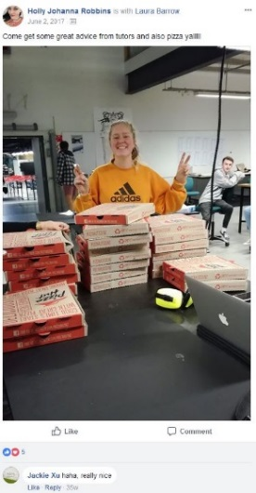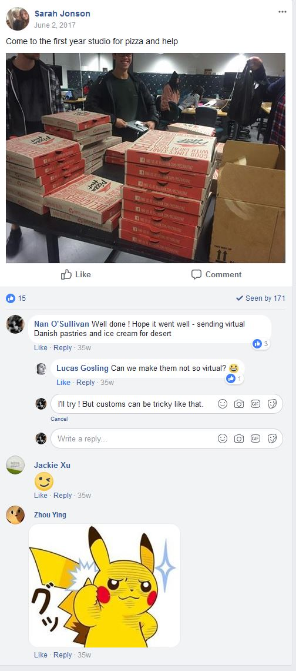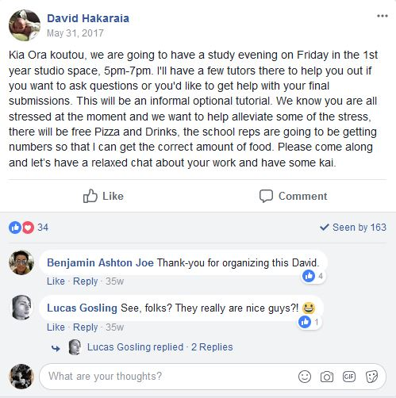For some students this is a difficult, at times confronting challenge as they have never had to recognise, investigate or articulate such concepts. As part of the process students are asked to connect with each other and staff to consider their work in progress. Study and pizza sessions are held to encourage the new students to come together to share ideas and skills, to help each other appreciate they are not alone in this new environment and to encourage them to ask for help.

Fig 2. Facebook post advertising the First Year Study and Pizza sessions

With an appreciation for the *We Eat Together* concept and the summation given by the Florida high school staff member, our first year programme agrees, “It's not just about eating pizza together but how they do life with one another" (McGlade, 2018).

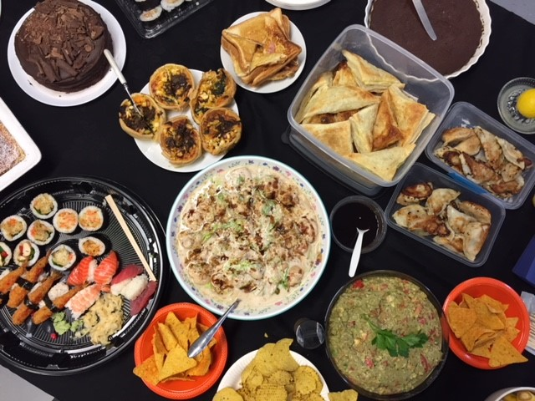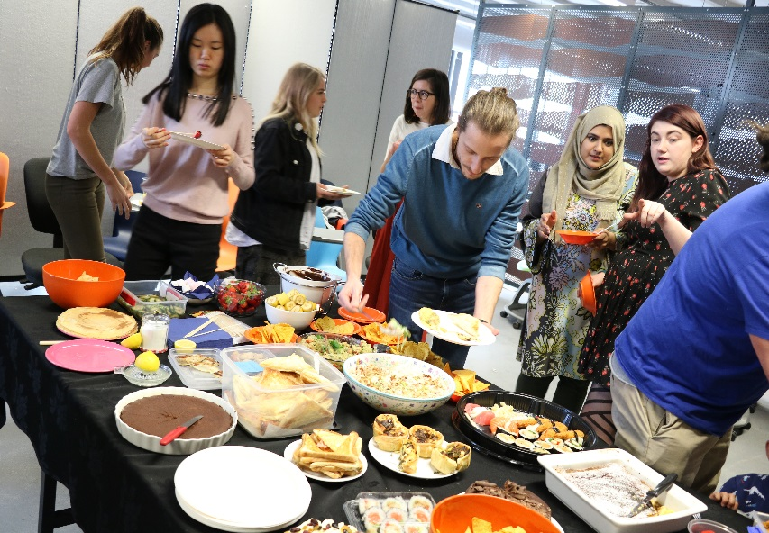As a part of both second year and fourth year core design papers students are asked to identify and develop personal yet place based understandings and approaches to their design thinking and practice. As with their first year studies, an appreciation of personal identity (*whakapapa*) is prioritised. Building on the visual articulations of this undertaken in their first year the students are now asked, to bring *kia* (food) to class. The purpose of this is to enable a connection through a shared meal where they can both give and receive something of themselves. Some bring food from their childhood and discuss the emotional connections to who was there when they ate it or who made it for them. Some brought family favourites that each generation now continues to make. Others challenged the group with culturally specific foods that many of the group were unfamiliar with.

Fig 3. Commensality between students that enabled cultural identities and legacies to be discovered and shared. (Reproduced with student’s permission)

The students use this experience to strengthen their appreciations of similarity and difference within their design strategies and to foster pathways as designers, towards positive social change and sustainable futures. As a part of this a number of students considered ways in which interpersonal connections can be made across space and time via commensality through both a visual articulation and a theoretically framed research papers. Within the theoretical approach students discussed that eating and drinking require a number of key social elements such as materiality, spatial arrangement and place, bodily experiences, mental expectations, and bonding/exclusion. The students began to devise design opportunities to tap into the dynamic social dimension they now appreciate exists around food. They expanded the current discourse that, “food goes beyond pure biological needs and discuss eating as an endlessly evolving enactment of gender, family, and community relationships”(Fahlander, 2010).

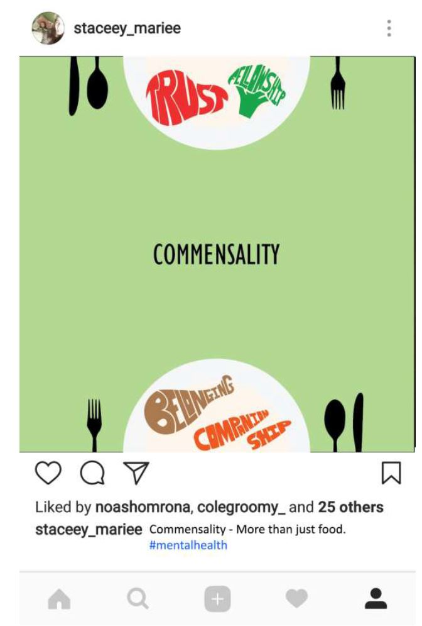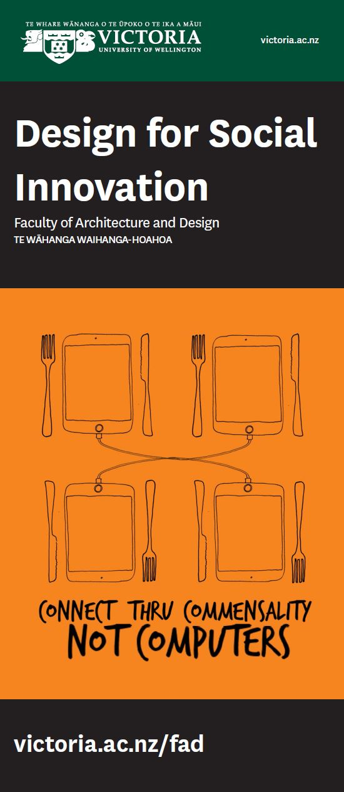

Fig 4. Posters designed by second year design students and summarise their personal standpoints as designers. (Reproduced with student’s permission)

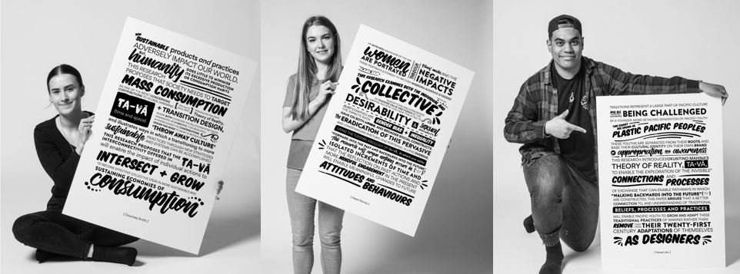Building on the shared ‘*kai*’ experience and to gain further appreciations of the connections that can be established students referenced Samoan academic Albert Refiti and posited that a community is an extension of our immediate family. “We should treat the family relationship as being part of a larger social extension. Being kind and understanding and expanding the precious circles of inclusion in which we function” (Refiti, 2017). Commensality, when undertaken as a family meal can enable a meaningful engagement and lifelong, intergenerational learning opportunities for those engaged in the group. With an appreciation for both *manaakitanga and* *Ta–vā* students discussed family or community based meals as a space that produced relaxed, fluid communication but also enabled the assimilation of social structures relevant to that group through reciprocity and respect of social behaviours.

EXAMPLE ONLY

Fig 5. Abstracts for the research essays that were supported by the posters above. (Currently formatting the relevant ones!)

As an important adjunct to the discussion and while acknowledging that “commensality directly relates to the establishment of positive social behaviours, the ability to deal with conflict through learning communication skills and also encourages both physical and mental wellbeing” (McIntyre, 2012 ), the students developed arguments that considered the placement of technology within the shared meal.

It was apparent from the class discussions that as a cohort, the second year students questioned technology in this particular space and discussed it as an obstruction to the social connectivity offered within commensality. The post graduate cohort were more inclined to critically challenge this point of view and look to find ways that digital technology can add to the inter-connectivity of the commensal meal. While considering Siegler’s article, *I Will Check My Phone at Dinner, And You Will Deal with It* the students asked how can the modern day usage of technology at the table become an extension of Simmel’s assertion that in spite of eating being an act of exclusive selfishness, the coming together to eat brings about sociologically significant moments of togetherness (Simmel, 1997 [1910]). The students further address both Ka’ili and Henare’s explanations that relationships exist beyond worldly and conceivable boundaries. The students agreed that the everyday experience of a shared meal is considered important for fostering togetherness but felt that an appreciation of interconnectivity though *Ta-Vā* and *kaupapa* Māori enabled a broader approach to the design and use of such technologies than the current discourse. A recent Human Centered Interaction (HCI) research study carried out by the Microsoft Research Centre acknowledged, if not some level of responsibility, the discussion around the negative impact of technology usage at the dinner table. “It [technology] has been accused of encouraging unhealthy food practices, detracting from positive familial interaction and taking attention away from the enjoyment of the meal” (Ferdous, 2016).

Their study, while conceding that there are efforts being made to address better health, education and mentoring of social behaviours within social eating experiences via technology, they also noted that of concern to both their study and Microsoft that, “what is underexploited here is the possible role and significance of technologies in contributing to togetherness during such commensal meals” (Ferdous, 2016). It is in this space, this paper argues, the intersection of Indigenous Wisdom and the Everyday as part of the Transition Design’s framework can synchronise to ensure that HCI research can maximise understanding and pathways to better connectivity within a more critical, culturally informed and holistic approach.

Incorporating these considerations is a post graduate project that considers the possibilities for social connection while dining in isolation: Smart Tray. This study was guided by the establishment of connections between place-based culture, technology and social behaviour. In doing so this research acknowledged Aotearoa’s cultural ideologies and the relevance these hold alongside the advancement of technologies and how these, when combined can offer solutions for positive and sustainable futures.

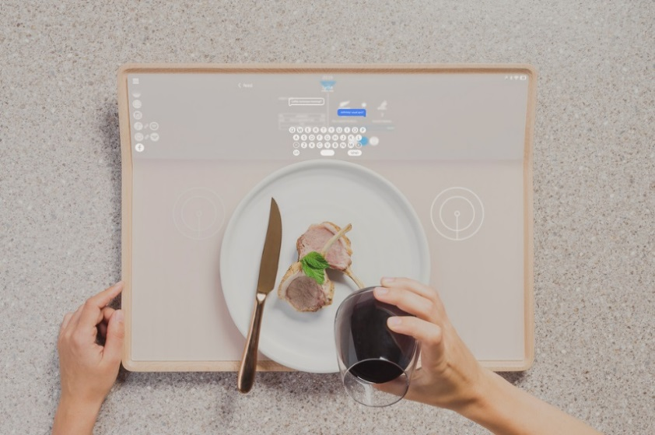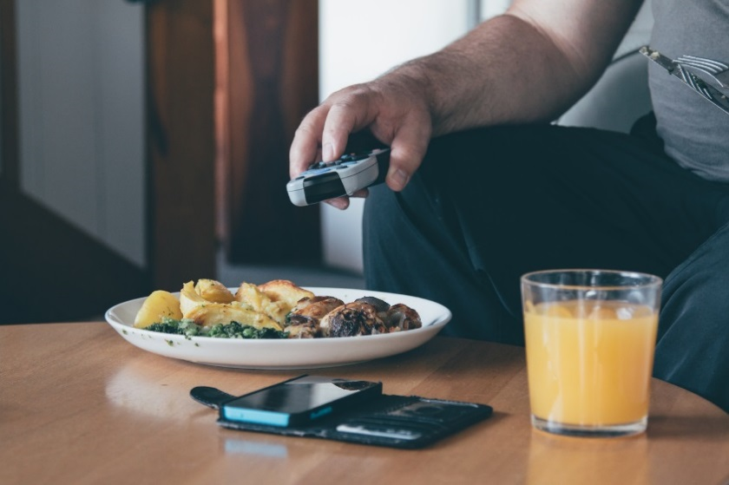Fig 6. Images from Smart Trays: Speculating the Future of the New Zealand Dining Experience. Victoria University School of Design, Masters thesis project 2016. (Reproduced with author permission)

Framed within Transition design, this paper has introduced commensality as the everyday context from which to explore the use of indigenous knowledge as agency to enrich current understandings of social connectivity within design thinking, process and praxis. By highlighting the understandings of reciprocity and respect imbued within *kaupapa* Māori and the Pasifika ideology of *Ta Vā* this paper offers an appreciation of how the inclusion of Indigenous Wisdom can enhance both design solutions and pedagogy. Having gained an appreciation for the value of indigenous knowledge and what it can offer the discipline of design in its efforts to make meaningful connections with society and how this can contribute to the endeavours of human centered research and development, a first step in this recalibration could be to reconsider the language and priorities used in such observations as the one made by the Microsoft study authors. This paper posits that the aim of the Microsoft funded study, would be better served by addressing the use of more culturally calibrated considerations within the issue of ‘togetherness’ that they identify. Within their statement, the word ‘underexploited,’ suggests, by the use of such oppressive language that Microsoft’s ultimate goal is not the use of technology to obtain advancements in democratised social connection or togetherness but an opportunity to advance opportunities for technology and positive financial bottom lines. Guided by *Ta-vā* and *manaakitanga* and looking to place the relationships between humans, things and nature before technological advancements, production or profit, this research posits that to better serve the global issues experienced as a result of ubiquitous computing a new appreciation of how to frame such a statement, or construct these studies is required. I argue, and conclude with the suggestion that these study would better be served if the preceding statement read as;

What is unacknowledged here is the positive impact of indigenous wisdom, the significance of traditional place-based understandings to interconnectivity and what these offer the advancement of technology by way of their ability to establish authentic and meaningful opportunities for togetherness.

FAHLANDER, F. 2010. The Nose, the Eye, the Mouth and the Gut: Social Dimensions of Food-Cravings and Commensality. . *In:* KJELLSTRÖM, F. F. A. (ed.) *Making Sense of Things: Archaeologies of Sensory Perception,.* Stockholm: Stockholm Universat

FERDOUS, H. S., PLODERER. BERND, DAVIS, HILARY, VETERE, FRANK, O'HARA, KENTON, FARR-WHARTON, GEREMY,& COMBER, ROB TableTalk: Intergrating personal devices and content for commensal experiences at the family dinner table. International Joint Conference on Persuasive and Ubiquitous Computing

2016 Heidelberg. ACM.

FICSHLER, C. 2011. Commensality. Society and Culture *Social Science Information* 50**,** 528-548.

HENARE, A. 2005. *Museums, Anthropology and Imperial Exchange,* Cambridge Cambridge University Press

HILARY DAVIS, B. N., FRANK VETERE, TONI ROBERTSON, MARGOT BRERETON, JEANNETTE DURICK, KATE VAISUITIS. Homemade Cookbooks: A Recipe for Sharing. Designing Interactive Systems 2014 Vancouver. AMC.

KA’ILI, T. Ō. 2005. Tauhi vā: Nurturing Tongan Sociospatial Ties in Maui and Beyond *The Contemporary Pacific,* 17**,** 83- 114.

MĀHINA, H. O. O. 2010. Tā, Vā and Moana: Temporality, Spatiality, and Indigeneity. *Pacific Studies,* 33.

MCGLADE, C. 2018. Eating alone at school: How four students began mission to end isolation. *Sun Sentinel*, January 18th 2018.

MCINTYRE, D. 2012 The great benefits of shared family meals. *New Zealand Herald*, May 9

MEAD, H. M. 2006 *Tikanga Māori* Hawai'i, University of Hawai'i Press

REFITI, A. L. 2017. How the Tā-Vā Theory Constructs a Spacial Exposition of Samoan Architecture. *Pacific Cultures* 40**,** 267-288.

SIEGLER, M. 2011. I Will Check My Phone at Dinner, And You Will Deal with It. Tech Crunch

SIMMEL, G. 1997 [1910]. The sociological of the meal? *In:* D.FRISBY, M. F. (ed.) *Simmel on Culture: Selected Writings.* London: Sage.

SOGAARD, D. M. 2015. Roundtable: Commensality *Kinfolk.* Oregon USA Kinfolk Magazine.

STAJCIC, N. 2103. Understanding Culture: Food as a Means of Communication *The Central European Journal on Social Sciences and Humanities* 77- 88.

SUSANNE KERBER, C. C., MORTEN WARMIND 2015. *Commensality from everyday food to feast,* New York New York Bloomsbury Academic

TERRY IRWIN, G. K., CAMERON TONKINWISE, PETER SCUPELLI 2015. Transition Design Provocation. *Design Philosophy Papers* 13**,** 3 -11.

TOWLE, M. 2016. We're here to help, we'll help anybody. *RNZ.* New Zealand Radio New Zealand

TURKLE, S. 2015. *Reclaiming Conversation.The Power of Talk in the Digital Age* New York Penguin Press

WENDT, A. (ed.) 1982. *Towards Oceania,* Auckland Macmillian Press Ltd.