**Title: Enlivening pedagogical methods in the classroom through visual arts**

**Abstract**

The challenge of decolonising the curricula presents us with engaging more relevant methodologies of teaching and learning local content appropriate for transformation. How do we enliven curricula and pedagogical approaches that can engender a sense of belonging for incoming first-year students and prevent polarising tendencies in the classroom? The arts are well positioned to disrupt the neat binaries and stereotypes and offer creative ways to explore patriarchal and colonial power relations. Arts provide safe and empathetic ways for incoming students to gain perspective of their situations from insider and outsider positions and develop a compassionate and enlarged view of the world.

In this paper we aim to clarify our understanding of decolonising frameworks in the classroom by introducing definitions and theory. We aim also to relate these frameworks to how we see the arts as placed to address decolonisation. This is linked to a discussion as to how we see arts-based approaches as a valuable contribution to understanding the Scholarship of Teaching and Learning in the South (SOTL). We also present a series of first-year classroom interventions as examples of praxis and approaches to create the conditions for democratising the classroom environment through directing visual processes to engage issues in a safe space.

**Introduction**

The challenge of ‘decolonising’ the curricula presents us with engaging more relevant methodologies of teaching and learning local content appropriate for transformation. How do we enliven curricula and pedagogical approaches that can engender a sense of belonging for incoming first-year students and prevent polarising tendencies in the classroom? We believe that the arts are well positioned to disrupt the neat binaries and stereotypes, and to offer creative ways to explore patriarchal and colonial power relations. The arts provide safe and empathetic ways for incoming students to gain perspective of their situations from insider and outsider positions and to develop a compassionate and enlarged view of the world.

In this paper we introduce definitions and theory to clarify how we understand decolonising frameworks in the classroom. We relate these definitions and theory to how we see the arts as placed to address them. This is linked to a discussion of how we see arts-based approaches as a valuable contribution to understanding the Scholarship of Teaching and Learning in the South (SOTL).

We also present a series of first-year classroom interventions as examples of praxis as a way to introduce and engage issues of identity and the decolonising discourse that has been dominating Higher Education since the so-called Fallist student movement, which started in 2016 and has also been referred to in this paper as the FeesMustFall student movement. It is our contention that the arts create the conditions for democratising the classroom space, and directing visual processes to engage issues such as the polarisation of race and class in the classroom.

**Theory: Decolonising curricula and SOTL**

What do we mean by decolonising the curricula?

In *Decolonization is Not a Metaphor* (2012), Eve Tuck and K. Wayne Yang point out the misuse of colonialism in the casual use of language when we refer to “decolonising our schools,” or use “decolonising methods,” or “decolonising student thinking”:

… we want to be sure to clarify that decolonization is not a metaphor. When metaphor invades decolonization, it kills the very possibility of decolonization; it recenters whiteness, it resettles theory, it extends innocence to the settler, it entertains a settler future (Tuck & Yang 2012: 3).

Tuck and Yang emphasise that decolonisation is not “a swappable term for other things we want to do to improve our societies and schools” (Tuck & Yang 2012: 3). In the light of their analysis, it may be more useful to use the term “coloniality” in the context of teaching in the arts and humanities, rather than colonialism or post-colonialism, which denote political or economic relations in which one nation’s sovereignty rests on another’s. Coloniality is more than the aftermath of colonialism. Nelson Maldonado-Torres (2010) explains coloniality in a way that highlights longstanding inequalities of power arising from colonialism manifest in culture, labour, intersubjective relations and knowledge production. It is “maintained alive in books, in the criteria for academic performance, in cultural patterns, in common sense, in the self-image of peoples, in aspirations of self, and … many other aspects of our modern experience” (Maldonado-Torres 2010: 97).

At a lecture at the University of Johannesburg in 2016, Maldonado-Torres went further by emphasising that “the very act of decolonisation generates anxiety. It unsettles one’s sense of well-being and belonging” (quoted by Hendricks and Leibowitz 2016).

Educationalist Ahmed Essop (2016) also recognises that decolonisation is too narrow and limiting a lens through which to engage the debate curriculum change. Decolonisation refers to the historical process whereby countries that were ruled by foreign powers obtain their independence. According to Essop, decolonisation in the context of Higher Education, seeks to affirm African knowledge and cultural traditions in universities, which remain dominated by western traditions.

Cheryl Hendricks and Brenda Leibowitz in their 2016 position piece in *The Conversation*[1] clarify that decolonisation of knowledge demands that “universities revisit their curricula and include – not in uncritical ways – epistemologies, texts and scholarly work that have been previously excluded or marginalised” (Hendricks and Leibowitz 2016). They confirm that students must play a central role in the decolonisation of knowledge by participating in the attempts to revisit how and what is taught. The consequence of not doing so, they warn “is to continue to be complicit in the reproduction of social and cognitive injustices and to condemn students to be perpetual consumers of knowledge” (Hendricks and Leibowitz 2016).

In this paper, we adopt the explanation by Achille Mbembe who provides a guide for educators confronted with decolonising the classroom as a site of engagement. He identifies the following challenges to consider:

* How we re-invent and dissolve power relationships in the classroom;
* How we create safe spaces in the classroom so that everyone feels a sense of belonging;
* How we disentangle ourselves from obsolete pedagogies and look at teaching and learning as co-creation; and
* How we change the paradigm of measuring achievement through quantitative assessment.

This understanding of decolonising seems to serve aptly as “a metaphor” for our use of the meaning of teaching and learning in the classroom situation, which is closer to enhancing a greater democratisation. Opposing Tuck and Yang’s comment that decolonisation is not “a swappable term for other things we want to do to improve our societies and schools” (Tuck & Yang 2012: 3), we use it here as a term that calls for inclusion, recognition and affirmation in the university, and an association that fits more closely within the social justice framing of the SOTL toward a greater sense of equity and expressions of invisible voices in the classroom.

Michael Samuel in his article Developing a Syntax for SOTL published in the first issue of *SOTL in the South* lays out the groundwork for a scholarship of teaching and learning in a South African context, and recognises the “inhumane practices which have violently seeped into the fabric of the Higher Education system” (Samuel 2017: 23). He also refers to the experience by students as “not recognizing the complex negotiations of self, structural expectations and personal and social responsibilities” (Samuel 2017: 23). He argues that the transformative agenda requires individuals, disciplines and institutions to become more comfortable with boundary crossing and urges scholars to “exhibit epistemic disobedience” (Samuel 2017: 33 - 34).

While decolonisation is an important catalyst for “epistemic disobedience” (Mignolo 2011), the syntax of SOTL provides a more appropriate language to address a methodology of practice. We agree with Samuel that “disruption is not inherently destructive, it is a bridge building force” (Samuel 2017: 34) and we argue that the arts, when used for transformation practices, can achieve the kind of new imaginative possibilities, responsiveness, relevance, resilience and robustness that this field of scholarship and practice calls for (Samuel 2017: 34).

**The Arts as scholarship and practice to enhance SOTL**

In the context of using the arts as transformational practice, coloniality becomes a vital lens in addressing a more democratic space. Given the widespread colonial history of Africa, coloniality is implicated in engaging with the diverse classroom. It is therefore important when teaching students, for the educator to be cognisant of recognising inclusion. If not, we, in the higher education system will continue to perpetuate the injustices of excluding black, indigenous, queer or poor African voices as less legitimate alternatives to European ones.

Hendricks and Leibowitz comment that students have pointed out if knowledge isn’t decolonised, academics, too, will remain perpetual consumers rather than creators and authors. They argue that part of the purpose of a university is to think through these broader societal challenges and to provide students with access to alternative ways of envisioning the world and interpreting their experiences (Henricks and Liebowitz 2016). Students have to play a central role in the attempts to revisit how and what is taught. This became evident in a panel about decolonisation at the University of Johannesburg when a student commented:

Please let us see ourselves within the degrees that are taught – otherwise, UJ, how is it an African university?[2]

Arts practices are relational. The relationship extends beyond the medium to collaborators, which constitute those from whom inspiration is gained, as well as audiences and ultimately it is extended to wider communities. According to Michelle LeBaron, a conflict resolution scholar, understanding the relational aspect of a conflict to be addressed is essential to knowing how to engage those involved. Transformative arts practices accent relationships; they are based in it and are focused on shifting it (LeBaron 2003).

Our challenge as educators is to enliven research, curricula and teaching approaches that can engender more ethical and empathetic relationships and to do so by introducing methods that require a deeper engagement with our students. From our perspective, the arts are well positioned to disrupt the neat binaries and stereotypes and offer creative ways to explore the messiness of patriarchal and colonial power relations. This paper introduces participatory and reciprocal arts practices in the classroom, which we argue deepens the critical capacities of staff and students, enables the classroom to become a safe space in which to take risks, as it enhances empathetic qualities among and between members of the group.

**An example of practice**

The second part of our paper consists of a series of classroom strategies in the Visual Art Department at the University of Johannesburg. Some of these strategies were introduced as an experimental classroom approach to mitigate risk and build cohesion among the incoming first-year students. We facilitated a series of workshops over a period from 2014 to 2016 which, in our assessment, has contributed to modest but improved changes in supporting students by providing additional coping strategies.

As initiators of the workshops, we were motivated to draw on approaches such as Appreciative Inquiry (Hammond 1998), creative arts-based strategies (Berman and Allen 2012), a capabilities approach (Sen 1999 and Nussbaum 2002, 2011) and whole-brain learning (De Boer *et al,* 2012). The methodologies we introduced into the classroom were experimental and spontaneous, but the principal philosophical approach used was asset-based or appreciative inquiry which is an approach that begins by asking students about their strengths and positive experiences and stories that they bring to the group rather than deficits or problems.

Innovative arts-based approaches for community engagement have been a long-time strength in the Visual Art Department, yet those strategies had previously been applied outside the formal classroom environment with senior students involved in community engagement programmes. The many years of community engagement in arts and social activism have provided valuable lessons to share in the process of addressing the issue of ‘intersectionality’ and greater equality in the classroom.

In the following presentation of first-year classroom workshops, we aimed to create a safe environment in order to raise awareness of issues and challenges facing students, such as transport, health, funding and family circumstances. The aim was also to use a peer-driven approach to change the dynamics in the classroom, to help the students to identify their strengths and to learn how to use them. The themes we wanted to address were asset-based approaches, such as building confidence, creating equality in the classroom, enabling co-operation and collaboration (watching each others’ backs) and animating a deeper experience of participatory citizenship.

**Introductions and Ice-Breakers**

The first workshop – gradually adjusted and refined over the years – introduced empathetic listening skills and teamwork to incoming first-year students. The initial workshop in term one was about getting to know each other. The first exercise required students to introduce themselves to each other in pairs, and each listener had to then introduce their partner to the class. In pairs that changed five to six times in the first hour, students were given two minutes each, to talk and listen in response to a series of questions that had to do with goals and dreams, passions and interests, early good and bad memories, fears and hopes for their first-year at University (Figure 1). Our students appreciatively shared with the group some of the revelations that delighted or amazed them about their peers and discovered more commonalties than differences.

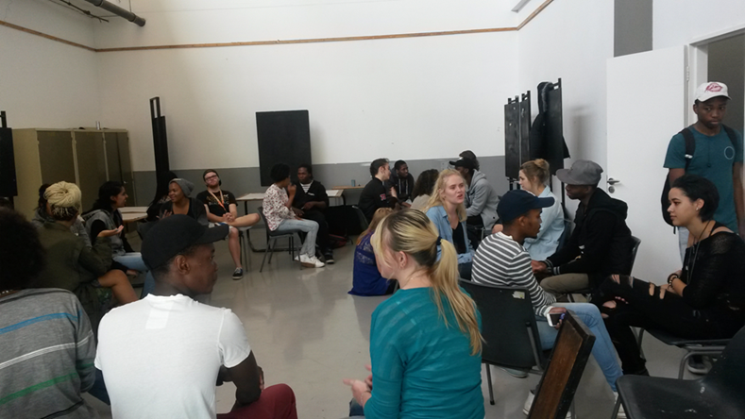

Figure 1. First-year visual art students in dialogue with each other, First Semester 2016. Photograph by Kim Berman.

An example of one of the team building exercises is using their combined bodies to make a human sculpture that could visually communicate a word. The possible words for this exercise included “colonisation”, “racism”, “stigma”, “democracy”, “ubuntu” and “privilege’. This exercise was conducted with groups of six or seven students who had 15 minutes to discuss their understanding of the selected word and agree on how they could represent that word. During reflective feedback after the session, they identified some of their learning experiences, stating that their ability to understand the body sculptures of the words reflected good teamwork, collective identity and the value of strong visual communication.

Another arts-based approach to enhance reciprocal dialogue and connection required the students to have non-verbal engagements with each other. First, in response to the question: “How are you feeling this morning?”, they were obliged to have a visual conversation with each other in pairs. They could use paints, markers or crayons on a shared sheet of paper, but were not allowed to say or write words. They then moved into groups of five or six, and worked collectively on a group image in response to a question related to their first-year experience as Visual Art students (Figure 2). The last exercise asked them to paint or draw a passion in their life and share something of the image/expression that they felt comfortable with.

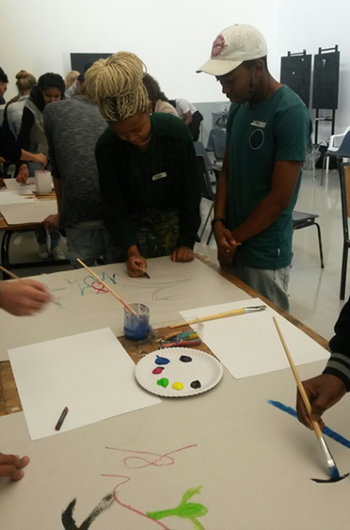

Figure 2. First-year visual art students having non-verbal visual conversations. Photograph: Kim Berman

The reflective verbal discussion, after the students shared their visual or embodied voices, was presented as an animated conversation that expressed commonalties, and shared confidences and narratives that surprised and made connections between non-predictable pairs. By the end of the session, during one-on-one and group sharing, the energy in the room had shifted from nervous, quiet and restrained to loud, energised, engaged and excited. New allies were formed and the ice in the room melted.

**Whole brain learning**

In the second series of the workshops, usually held at the beginning of the second semester, we adapted a model of “whole-brain learning” that viewed the class as a system that required both sides of the brain to function as a whole. This approach was influenced by an article written by an inter-disciplinary team at the University of Pretoria. Anne-Louise de Boer, Theo Bothma, Pieter du Toit and Detken Scheepers from the Faculty of Education, Information Sciences and Health Sciences constructed in 2012 what they call “a Comprehensive Learning Style Flexibility Model for the Innovation of an Information Literacy Module” (De Boer et al 2012).

In order to adapt the approach for presentation to the class, on flipchart sheets, we separated and defined the four different brain functions of all the qualities in each modality (Figure 3), with a diagram of quadrants A, B, C and D, which itemised each preference’s different qualities.

The A quadrant reflects a strong preference for thinking analytically and logically and for quantifying. Students in this mode favour working as individuals and not in groups, and prefer challenging problems to solve, particularly in cases where the purpose of the project is clearly spelt out. They like fact-based lectures and presentations of well-researched topics.

The B quadrant similarly displays a strong preference for controlled, structured and organised thinking modes. Students in this mode might struggle in an environment that does not embrace order and structure. They prefer detailed lectures that explain topics step by step with checklists, in order to ensure they are on the right track.

The other quadrants present a different picture. What motivates those with a C quadrant preference is being involved and able to share experiences with others. These individuals prefer to work in groups, enjoy team efforts and favour hands-on activities. They struggle with data overload, analysis and restricted time for expressing ideas. They prefer group discussions, role-play and sharing personal experiences.

The preference for the D quadrant is also holistic involving the big picture. Students in this mode are imaginative, and do not want detail. They thrive on discovery, experimenting and synthesising parts into a new concept. They do not like lectures in the traditional form; they prefer brainstorming ideas, playing games or drawing mind maps (De Boer et al 2012, 194).

We then asked the students to stand next to the quadrant characteristics they felt best described them, or with which they identified most closely. For example, in simple terms: Left: organised, Right: experimental. Interestingly the class divided themselves quite evenly; we then blindfolded students and they met in the middle of the room to find a partner from the opposite group.

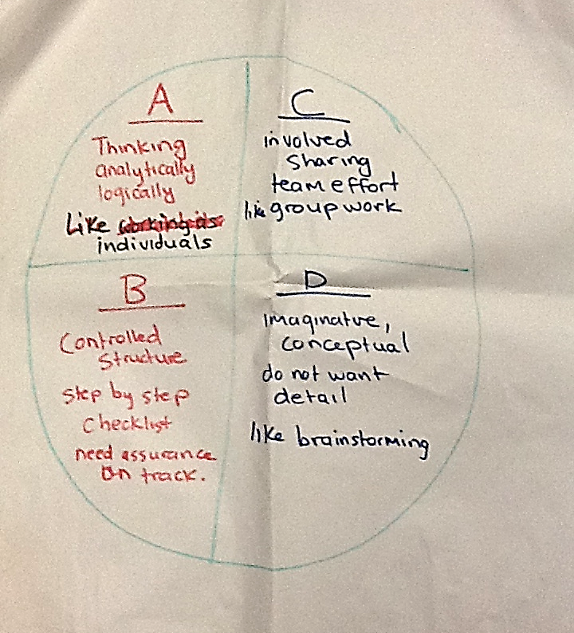

Figure 3. Whole Brain Learning workshop 2014/15. Chart used to divide the class according to modalities of brain functions. Photograph: Shonisani Netshia.

As the two lecturers involved in the facilitation, we made sure the students were grouped in twos and in some cases threes; those placing themselves in between quadrants were placed in a group of three with two students who had distinct preferences. They then “interviewed” each other, shared and recorded all the individual strengths that each was bringing to the partnership. They also shared some of their weaknesses, and discussed between them, how the different strengths in the combination could contribute to and complement the liabilities in the partnership. These small groups became accountable to each other in and out of the classroom for a limited period over the next term and until the next group meeting.

As a class, we discussed how each student would be responsible for ensuring that the other member/s of their group met the expectations of each other that they had agreed on. Should one of them be late for class or fail to hand in an assignment on time, for example, that student’s partner/s would be held responsible. Different strategies were agreed on by the group as to how they would hold each other accountable, including implementing a fine for no or late delivery of work.

We then assessed the success of the workshop with the assistance of the staff who teach these students. The feedback from a first-year theory teacher was that she was amazed by improved attendance, and the fact that someone in the class always had an explanation for a missing student; she understood it to be because they always covered for each other. The theory results also improved as peer partners supported each other with research and writing skills.

**Reflexivity**

Another workshop we implemented with different groups of first-year students toward the last term of their academic programme focused on self- reflection and evaluation. In this workshop the students were asked to write a short reflective essay on “Getting to an A”. They were given the following two quotes by Benjamin Zander (an educator and conductor of the Boston Symphony Orchestra) and asked to respond through writing a personal reflection:

The practice of giving [yourself] an A transports your relationships from the world of measurement into the universe of possibility....This A is not an expectation to live up to, but a possibility to live into (Zander 2000).

In the measurement world, we set a goal and strive to achieve it. In the universe of possibility, we set the context and let life unfold (Zander: 2000).

Each student was invited to express an aspiration to find his or her own level of excellence and a sense of agency with regard to the group. Some of the students’ responses were as follows:

“... by setting goals for myself I create a path and opportunities where I can better myself as an individual”; and

“... it is not enough just to have abilities, we must learn to recognise them and use them appropriately”.

Colleagues and tutors commented on generally good morale, improved performance (and pass-rates), stronger motivation and cohesiveness among the second- and third-year classes who followed the first-year group workshops.

**Who is (not) an African?**

This final presentation of a curricular intervention in the final term of the first year class demonstrates how a visual art project can apply these claims for creating a safe and dialogical space in order to deepen critical reflection and take creative risks. By the end of 2016, the #feesmustfall student movement and calls for decolonising the classroom had caused renewed tension and polarisation along race lines in the classroom. The class under scrutiny consisted of approximately 40% white students and 60% black and mixed-race students. This project (which replaced the Reflection workshop described above) adapted classes in the printmaking medium of drypoint to respond to some of the current debates and was led by a recently graduated (white) Masters student, who is a new lecturer, and had a close working relationship with the students, who she was able to engage with as peers, as well as students. This relationship also extends the notion of coloniality through the consideration of the role of project leader as “a co-creator in a democratic research project” which counters the notion of the idea of “academic expert” (Boyte 2009).

We provided selected examples of the same first year students’ artworks that respond to the curriculum-integrated project called Who is (not) an African? This printmaking project confronts aspects of diverse identities in the classroom using multi-modal approaches. To introduce the research and engagement with the project, students participated in multiple methods of pedagogical approaches which included team exercises, group discussions in- and outside the classroom, PowerPoint presentations and video presentations by senior students. First year students were able to engage in debates with senior and post-graduate students who deal with themes of “whiteness” and “blackness” in their artworks. They were also able to attend a discussion with a (black) doctoral student on Post-African studies.

To learn the technique of intaglio drypoint, they were tasked with doing a series of exercises by researching and then imitating the style of an “old master” such as Rembrandt (in order to encourage them to understand the value of the past) and then they were tasked to take a “selfie” with their cell phones and using the “old-master’s” drawing style to reinterpret an expression of the contemporary self. The final component of the project required the students to interpret the theme of who is (not) an African by composing a self-portrait set in a specific context. Students’ reflections on their own learning from this project as well as a visual analysis of individual works reveal how they see themselves in a process of “becoming” in a “decolonising” political and educational landscape.

Two first year white male students both struggled with being confronted with their own understanding of whiteness and privilege in post-apartheid South Africa. Student One’s drypoint entitled *Of Rags and Riches* (Figure 4) consists of three different depictions of coins. The bottom left coin depicts a Kruger Rand symbolic of the student’s ancestry dating back to the Dutch and British settlers. In depicting this coin, he has replaced the traditional springbok, which appears on the original coin, with a self-portrait wearing a crown of headphones. He sees the headphones, as well as the car depicted on the third coin, as symbolic of the materiality associated with white privilege. The lion in the centre coin of the print represents the pride of his connection to his Dutch/ Flemish heritage. The text in all three coins has been written backwards as a metaphor of his world being turned upside down and back to front. He includes an imprint of a shoe at the top and bottom of the work that represents a physical symbol of treading over his heritage. He reflects further on his response to Who is (not) an African?:

As a white male living in South Africa, I am forced to feel apologetic about the past of my family, as well as constantly being required to have a need to wash away my heritage. I am a born-free, and refuse to be ostracised for sins of the past that I had no part in. All I once knew and accepted has been flipped on its head: my heritage is now different to what I used to believe, my ability to appreciate what has been provided for me is hated, and the pride I had for my family and place in the world, disrupted.

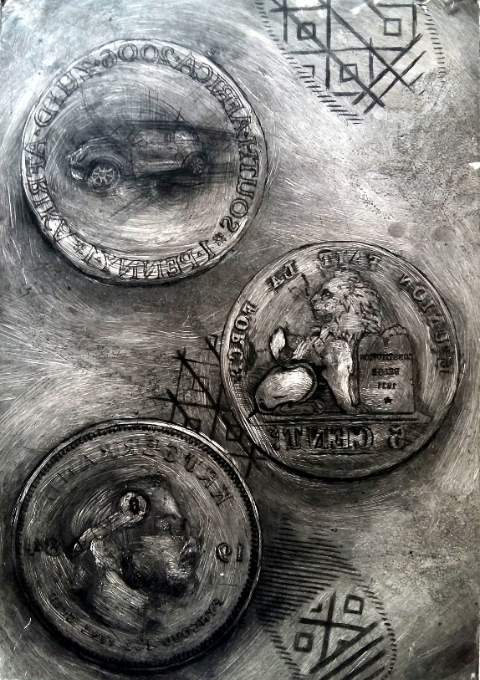

Figure 4. Student One. *Of Rags and Riches* 2016. Drypoint and monoprint. 29.7 x 42.0 cm.

Student Two’s print *#Privilege se Poes* (Fig 5) also grapples with being confronted by white privilege. In his statement that accompanies his print, he talks about his anger about the stigma he feels as a white male in post-apartheid South Africa.

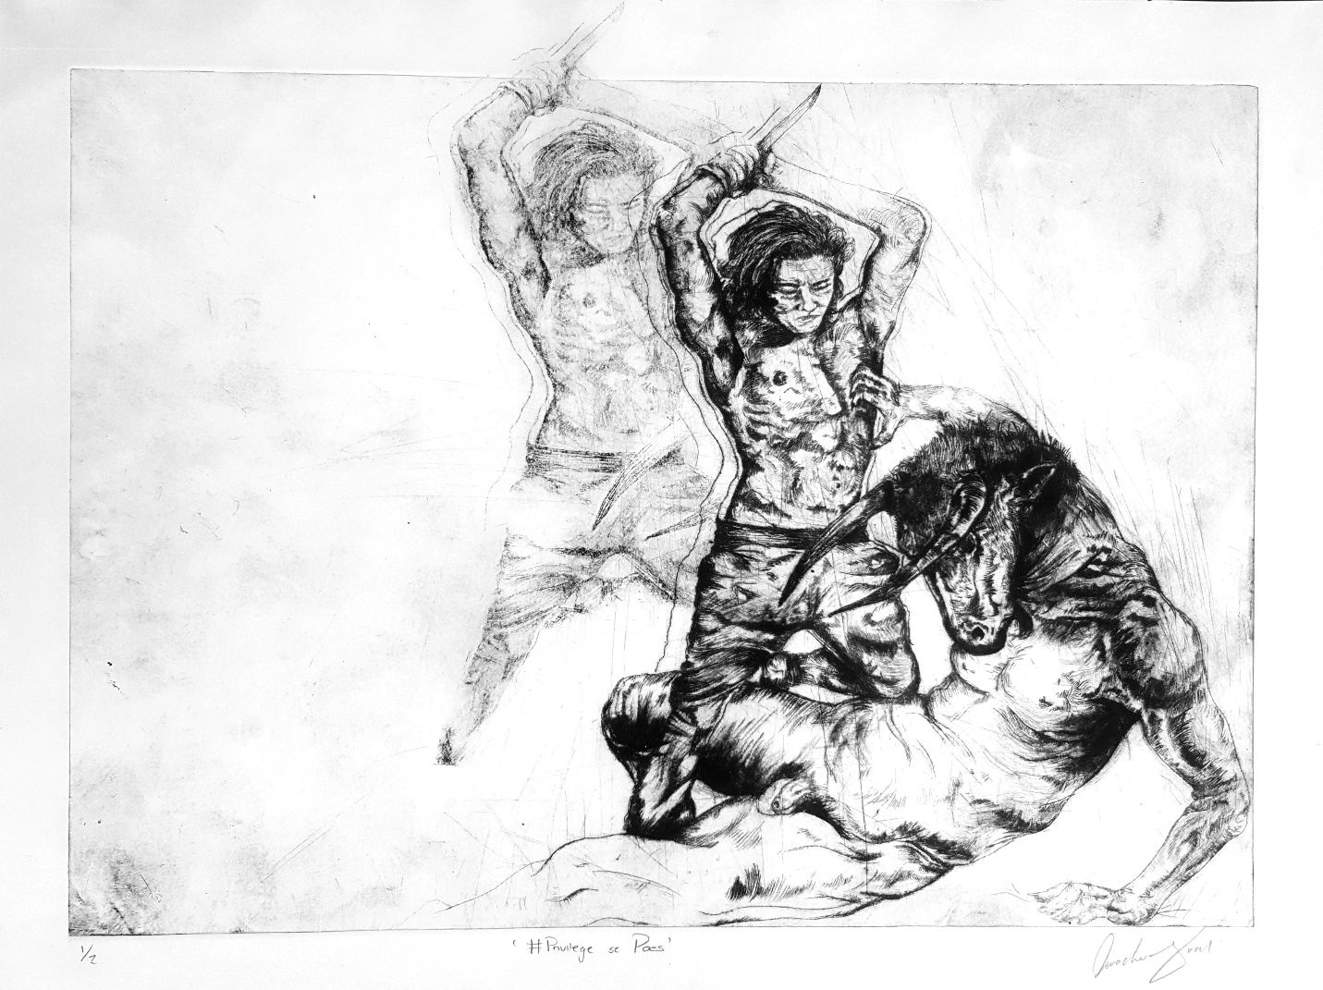

Figure 5. Student Two. *#Privilege se Poes* 2016. Drypoint. 29.7 x 42.0 cm

He explains:

In this print I am slaying a Minotaur that is representative of white privilege. By killing this Minotaur I am trying to break away from the stigmas attached to being white, such as being placed in a position whereby due to the colour of my skin I am seen as privileged. The fading away of the Minotaur’s leg represents this idea that is vanishing slowly, but still he is still capable to get up and attack me. I have placed myself in a position of power where I am a warrior about to defeat my opponent. This alludes to the fact that I am now bigger than my judgements, and that I have a reason to be able to stand tall.

Student Three, a black woman, responded to the question Who is (not) an African? by representing herself as an empowered African female figure that embodies qualities of strength and power. Her work, entitled *Victor* (Figure 6) consists of a self-portrait with the figure wearing an African headdress comprising traditionally male African symbols, such as elephant tusks and the horns of a bull. She incorporates symbols of the cross and holy Trinity to signify her Christian beliefs as well as the feathers of pigeons and other birds representing both female qualities of peace as well as the traditional use of feathers by amaXhosa warriors on returning victorious from battle.

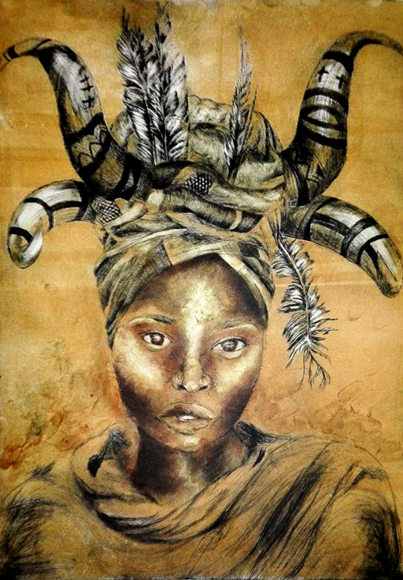

Figure 6. Student Three. *Victor*. 2016. Drypoint and monoprint. 29.7 x 42.0 cm.

She explains her work thus:

In Zulu culture, when the male victor would return from fighting a war he would be crowned with a crown containing elephant tusks. The crown symbolises the warrior’s strength. I see myself as a South African woman warrior. I wear a traditional head wrap, and can hold my own power that traditionally belonged to men.

**Findings**

The Visual Art Department at the University of Johannesburg has a diverse group of first year students and through this workshop, it became evident that their lived experiences and realities inform their actions, performance and success at university. In the first workshops students, responded positively to having a safe space to communicate with their peers and they came to appreciate differences and diversity in a team. They became accountable to and for each other, felt a greater sense of ownership and belonging, acquired a stronger work ethic as a group and developed a sense of community. Each student’s voice was heard by their peers, and as they participated in the workshops, they were able to experience empathetic listening and address issues of privilege and struggle. Furthermore, through their shared stories they became closer. Teambuilding workshops can be used as a transformative tool or platform to remind students that in order for change to happen they have to be willing to embrace their strengths and weaknesses, as well as to challenge lecturers’ perceptions about them (Fisher-Yoshida et al 2015, 3).

In the last project of the year, we argued that the ground was laid for students to take greater risks, confront their own identities with honesty and express their differences, including anger and resentment. Vigorous conversations took place where students could listen to and question senior students’ artistic responses and formulate their own positions. It became clear that creating a safe space in the classroom where each voice can be heard and appreciated allows for critical conversations and empathy of diverse positions.

Through the implementation of creative interventions, it is possible to influence students positively beyond the imperative to curb poor pass rates. We believe that supporting students’ agency though creating safe spaces for dialogue and exchange can provide a more fertile environment for a more meaningful and reciprocal learning experience. Meaning making is the core of education, for it to be useful. According to Mary Stone Hanley, without relevancy and usefulness, learning is vacuous and alienating, and resistance becomes a factor as learners try to re-establish their agency (Hanley 2002).

This loss of agency is reflected in the resistance students have expressed to the current state of alienation that so many students, who struggle financially, feel in the higher education environment. Lorna Holtman, Delia Marshall and Cedric Linder distinguish between formal access and epistemological access, and in doing so, note that many students, particularly those from disadvantaged communities, find it far more difficult to gain “epistemological access”[3], or the understanding of the unwritten and unspoken rules which are part of institutional culture (2004, 185).

While these series of interventions conducted in 2016 appeared to have had a positive impact on this group’s capacities to engage and confront contested identities and their positionalities, a year later, the cracks seem to be showing, and revealing some of the impact of “disrupted epistemologies”. In 2017, this group of students was in their second year of study[4].

While we agree with Samuel that disruption can be seen as a bridge-building force, there can also be difficult and painful fall-out. “Epistemic disobedience” referred to by Walter Mignolo refers to “the colonial wound”, “the unveiling of epistemic silences” and “rights of the racially devalued” (Mignolo 2009: 3-4). In this process, the racial power dynamics in the classroom are disrupted; certainty and confidence are replaced by anxiety and mistrust among some students, and a new-found power that sometimes translates into bullying is assumed by others. Essop warns against what he terms “racial essentialism – replacing white with black or Freud with Fanon; and social conservatism, which pits modernity against tradition” (Essop 2016).

Part of our purpose, as what Samuel calls “just teachers” ( Samuel 2017: 23), is to collectively think through these broader societal challenges with our students and provide them with access to alternative ways of envisioning the world and interpreting their experiences. As Alex Broadbent, the Dean of Humanities and co-director of the African Centre of Epistemology and Philosophy at the University of Johannesburg, states, a lot of formerly unvoiced and unheard ideas will come to light in this way: “The process of critical scrutiny is essential to the success of this project – and nobody gets a free pass” (Broadbent 2017).

The arts with multiple perspectives and modalities are a means to rich integrative education with porous boundaries that allow accessibility. Possibilities for expression, imagination and improved skill levels expand imagination and “push against external and internalized dominance by releasing the freedom to demand recognition of their own identity and dignity, to find a way out of no way” (Hanley 2013: 10).

The challenge of decolonising the curricula presents us with catalysing opportunities for engaging more relevant methodologies of teaching and learning local content. Arts and design educators are well placed to facilitate radical ways of engaging students and including a range of modalities that expands access and recognises diverse resources for meaning making and learning. Social justice education embraces cohesive connections to educate active and empathetic students as citizens. Diverse approaches go a long way in addressing the legacy of coloniality and inequality.

**Acknowledgements**

The authors would like to thank the first year class of 2016 for their consent and participation and for their permission to include their statements and visual contributions in this paper. We also appreciate the contribution of Heidi Mielke who lead the first-year printmaking project*:* I am (not) an African.

Thank you to Elizabeth Rankin for her comments on an earlier version of this paper and to Robyn Sassen for her insightful editing of this article.

**References**

Berman, K and Allen, L. 2012. “Deepening students’ understanding of democratic citizenship through arts-based approaches to experiential service learning” *South African Review of Sociology* 43 (2): 76-88.

Boyte, H. C. 2009. *Civic agency and the cult of the expert*. Dayton, Ohio: Kettering Foundation.

Broadbent, Alex. 2017. “It will take critical, thorough scrutiny to truly decolonise knowledge” *The Conversation*

<https://theconversation.com/it-will-take-critical-thorough-scrutiny-to-truly-decolonise-knowledge-78477>

De Boer, A., Du Toit, P., Bothma, T. and Scheepers, D. 2012. “Constructing a comprehensive learning style flexibility model for the innovation of an information literacy module”. *Libri* 62: 185–196.

Essop, A. 2016. “Decolonisation debate is a chance to rethink the role of universities” *The Conversation*

<https://theconversation.com/decolonisation-debate-is-a-chance-to-rethink-the-role-of-universities-63840>

Fisher-Yoshida, B., Geller, K.D. and Schapiro, SA. 2009. “New dimensions in transformative education” *Counterpoints: Innovations in transformative learning: Space, culture, & the arts* 341:1-19. Peter Lang AG.

Hammond, S.A. 1998. *The thin book of appreciative inquiry*. (second ed). Plano, TX: The Thin Book Publishing Co.

Hanley, M. S. 2002. “Learning to fly: Critical multicultural education through drama”. *Arts and Learning Research Journal*. 18(1), 75-98.

Hanley, M.S. 2013. *Introduction: Culturally relevant arts education for social justice: A way out of no way*. Routledge, New York

Hendricks, C and Leibowitz, B. 2017. “Decolonising universities isn’t an easy process-but it has to happen” *The Conversation*

<https://theconversation.com/decolonising-universities-isnt-an-easy-process-but-it-has-to-happen-59604>

Holtman, L., Marshall, D. and Linder, C. 2004. “Widening (epistemological) access: Two undergraduate science courses” In *Curriculum responsiveness: case studies in higher education* ed. H. Griesel, South African Universities Vice-Chancellors’ Association, Pretoria. 185-216.

LeBaron, M. 2003. Bridging cultural conflict: A new approach for a changing world. John Wiley: San Francisco.

Mbembe, A. 2015. Decolonising knowledge and the question of the archive. Public lecture given at the Wits Institute for Social and Economic Research (WISER), University of the Witwatersrand, Johannesburg. Available at http://wiser.wits.ac.za/content/achille-mbembe-decolonising-knowledge-and-question-archive-12054 (accessed April 2017).

Nussbaum, M. 2011. *Creating capabilities: The human development approach*. Cambridge, Belknap Press.

Maldonado-Torres, N. 2010. “On the Coloniality of Being. Contributions to the Development of a Concept” In Mignolo, WD, and Escobar, A (eds) *Globalization and the decolonial option*. London: Routledge. 94-124.

Mboti, N. How to identify courses or modules that need decolonising, and how to go about decolonising them? Posting by Loïse Jeannin 9 March 2017

<http://sotlforsocialjustice.blogspot.co.za/2017/03/how-to-identify-courses-or-modules-that.html>

Mignolo, W. 2011. “Epistemic disobedience and the decolonial option: A manifesto” *Transmodernity: Journal of peripheral cultural production of the Luso-Hispanic world* 1(2). ssha_transmodernity_11807. Retrieved from: <http://escholarship.org/uc/item/62j3w283>

Morrow, W. 1993. “Epistemological access in the university” *AD Issues* 1(1): 3-5.

Samuel, MA. 2017. “Developing a syntax for SOTL” *SOTL in the South* 1 (1): 19-38.

Sen A. 1999. *Development as freedom*. Oxford: Oxford University Press.

Tuck E. and Yang, W. 2012. “Decolonization is not a metaphor”, *Decolonization: Indigeneity, education & society* 1(1): 1-40.

Zander B. 2000. *The art of possibility*. Harvard Business School Press, Penguin.

1. We reference and cite authors including university thought leaders such as Essop, Leibowitz, Hendricks and Broadbent from “The Conversation” a public e-forum for public positions on aspects of decolonisation as it affects the universities in this current climate.
2. (<http://sotlforsocialjustice.blogspot.co.za/2016/03/first-seminar-at-uj-decolonizing>)
3. The term ‘epistemological access’ was first coined by Wally Morrow in 1993 who proposed open access for students to ‘the goods which the university distributes’ (Morrow 1993:3).

  
4. An observation that seems common to other second year programmes in our faculty is that the students who began studying at the university at the time of the *Feesmustfall* movement in 2016 seem to have been specifically affected.